Website Design Project 22-23

The website design project was casino themed and here is my website that I was told to do

Starting off with the home page:
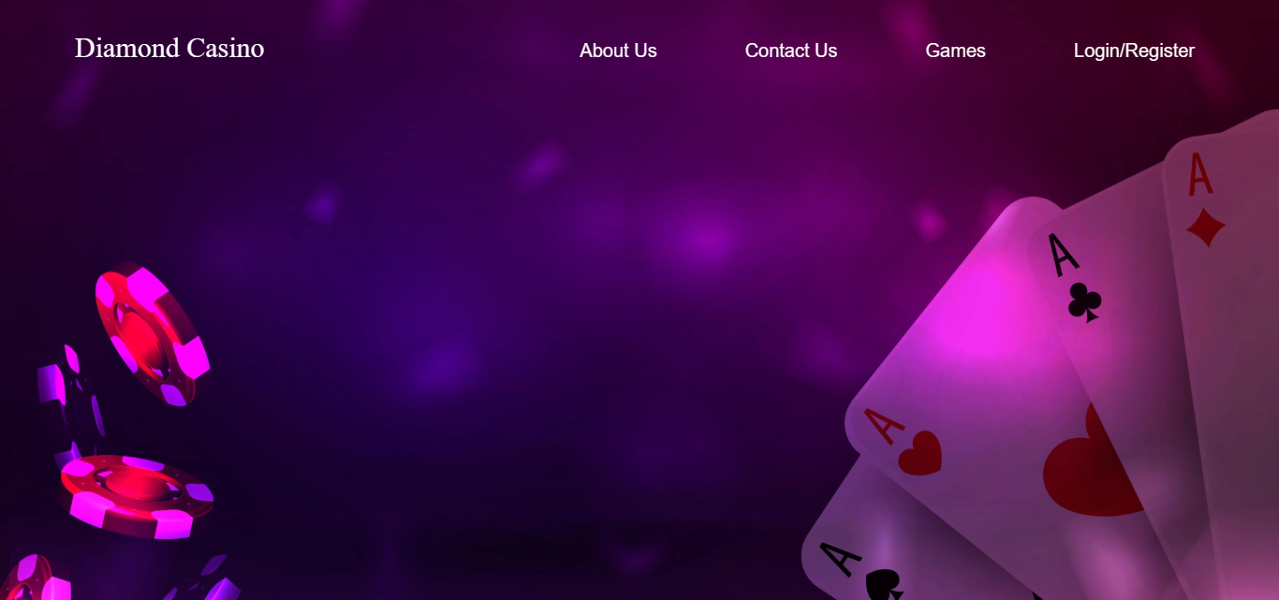

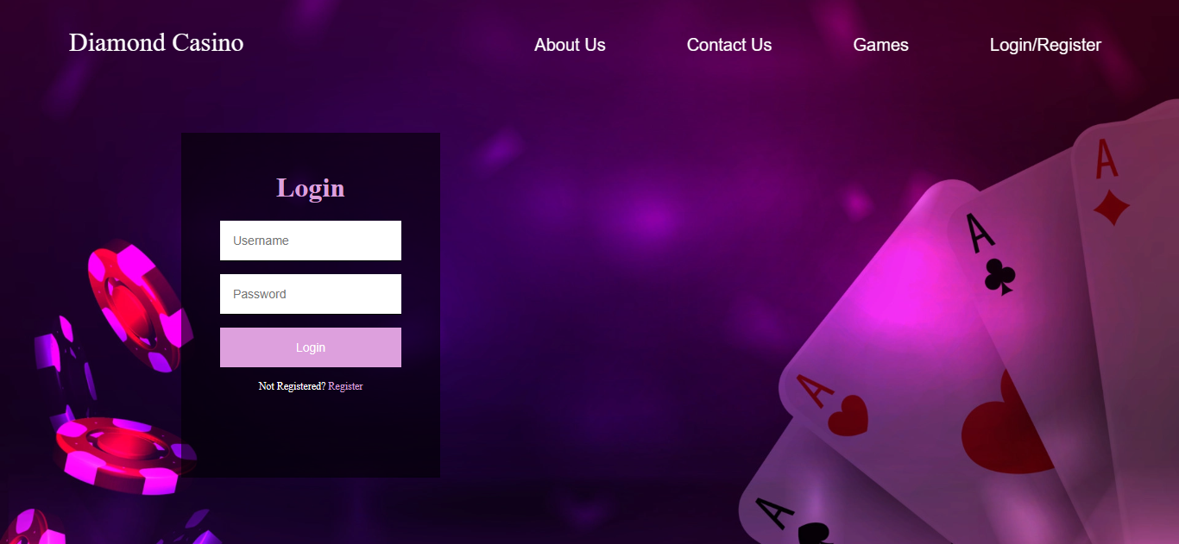
The home page also provides you with the login and register forms:

Register form:
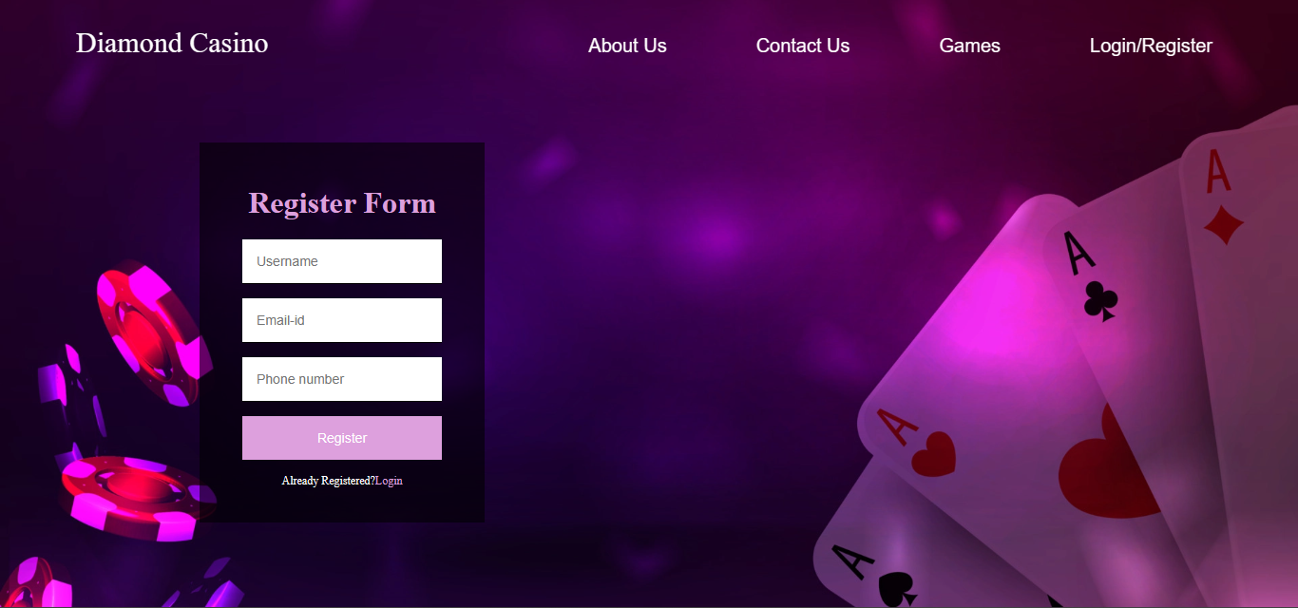

The website also has an about us and contact us page:


Contact Us Page:
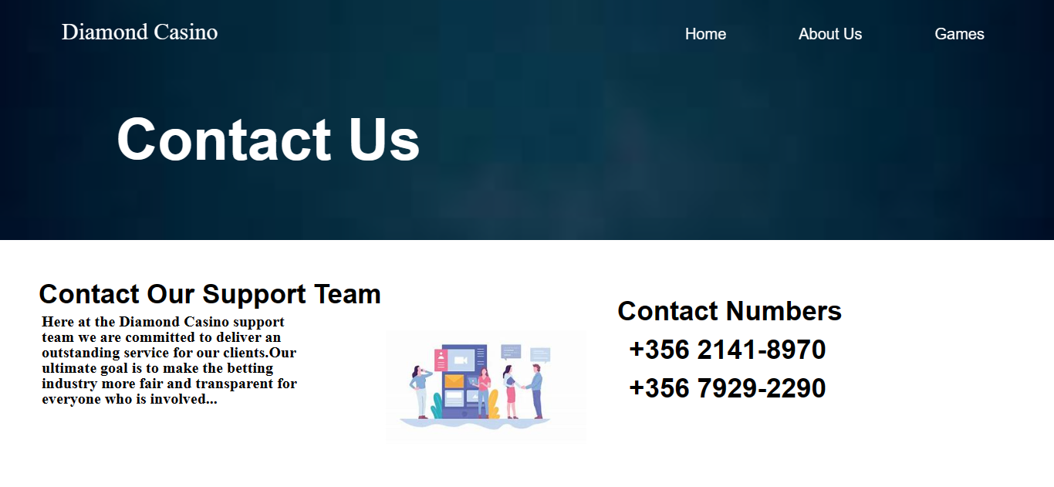


There is another page which includes all of the websites 9 casino games:

Once you click on one of the games it will open a background image:


Another game:
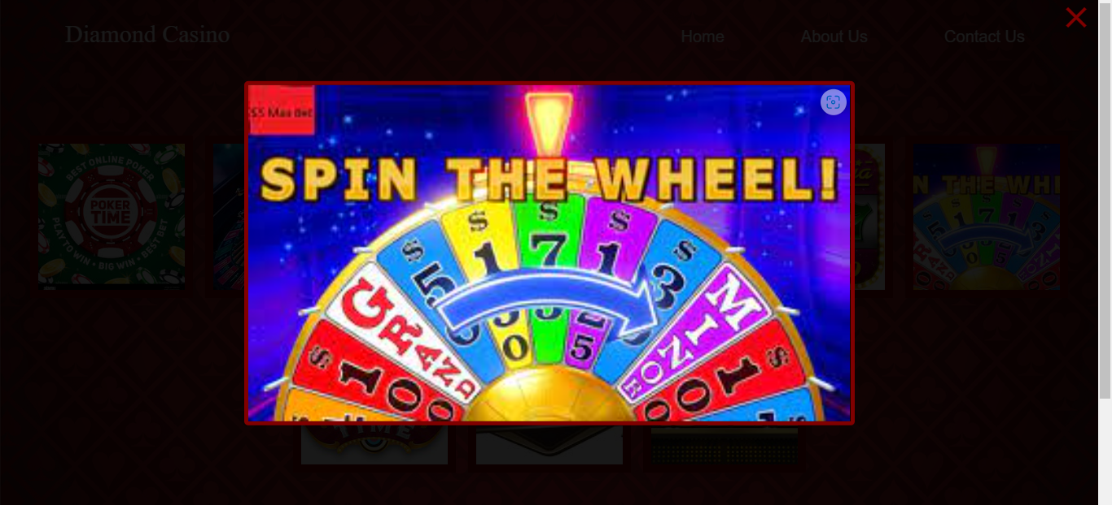

This was all of the website and there was a few pictures that showed the functionality of the website. Another task that was required to do was a carousel slider and the following images are how it was made.

The Carousel slider has a total of 4 slides that represent the web that was created. At the bottom of the page there will be a progress bar which you can see circled in a red colour to show where you are at that moment:
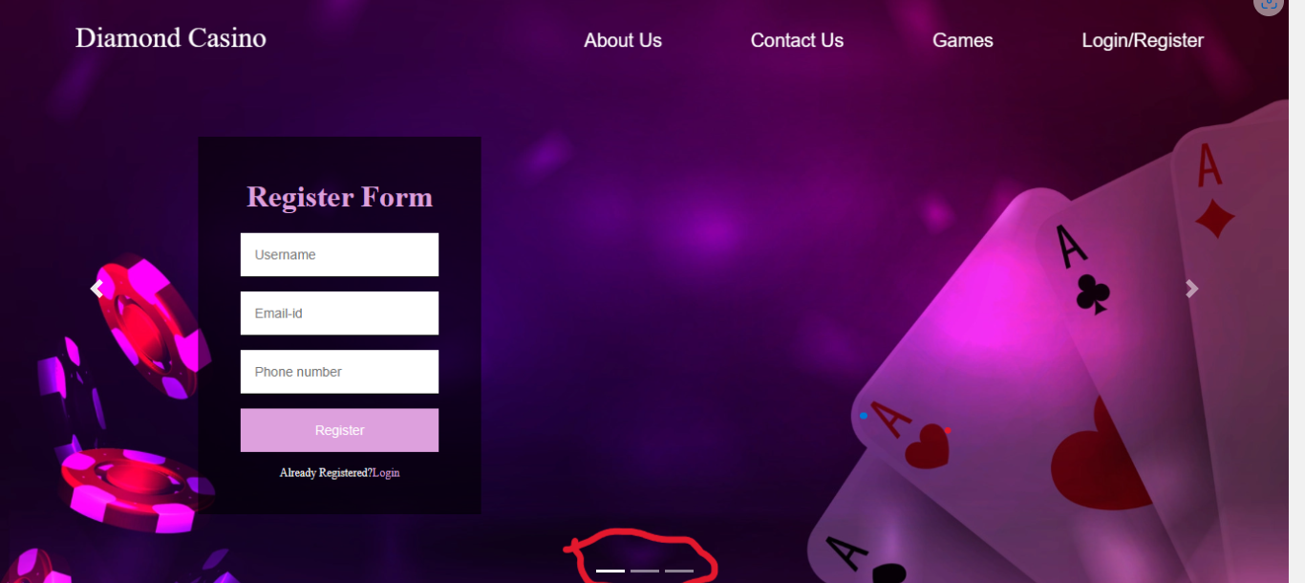

Another feature of the carousel slider is that you can change from one slide to another which are circled in red if you simply don’t want to wait for it to change by itself:
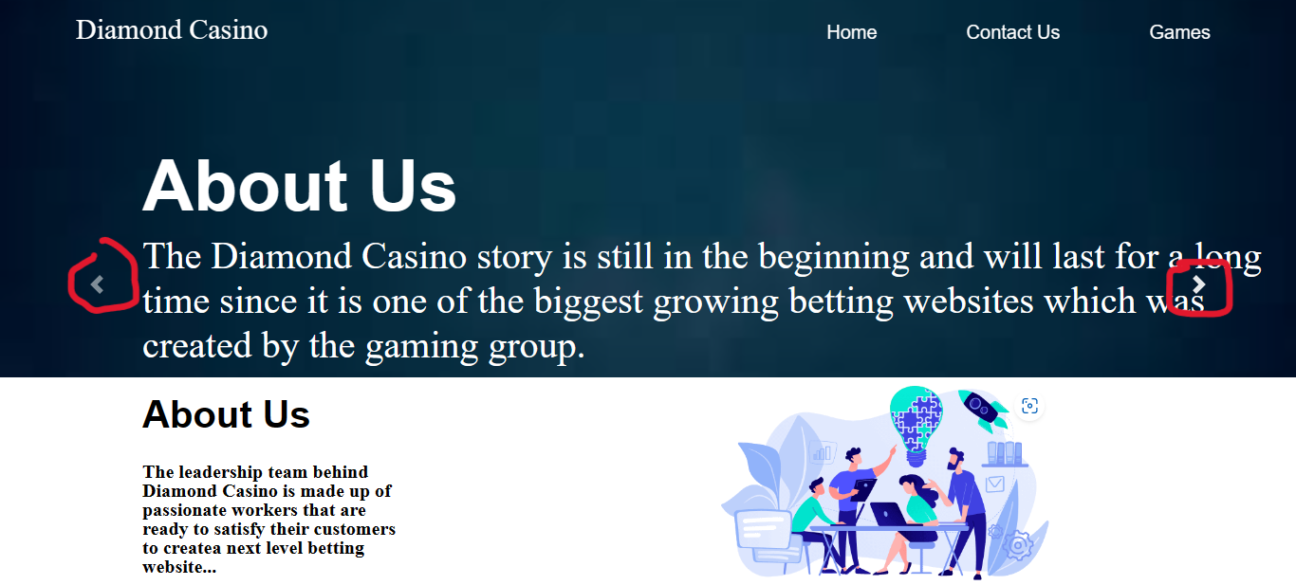

This is the code that was made for the carousel slider to work properly. The highlighted code shown below is one of the most important things of the carousel slider because if it wouldn’t be it the carousel slider wouldn’t work as a slideshow:
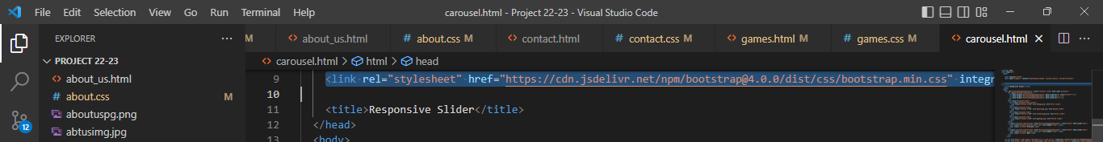

In this screenshot there is the code of the 4 slides:
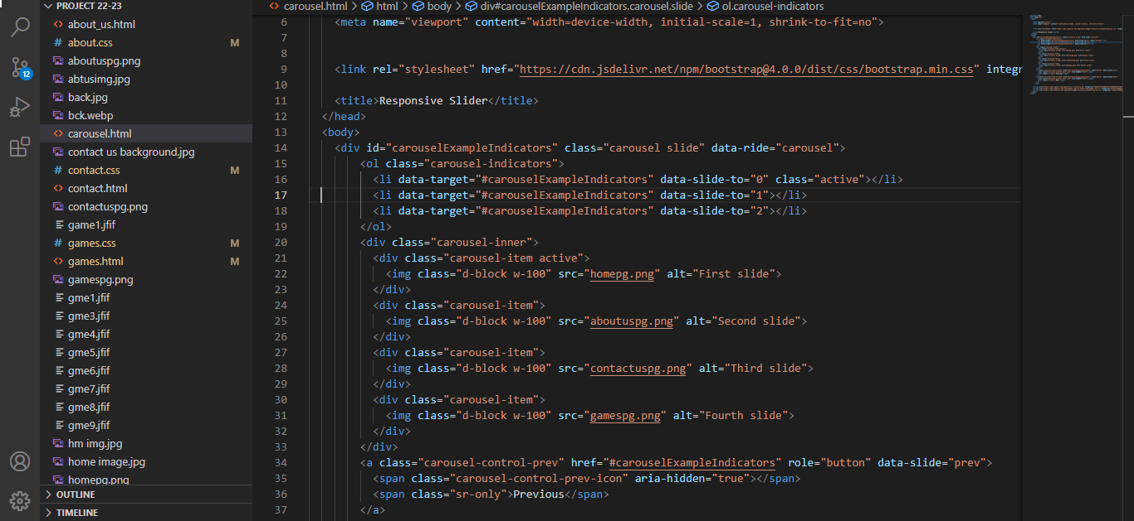

Remaining which connects it to jQuery code:
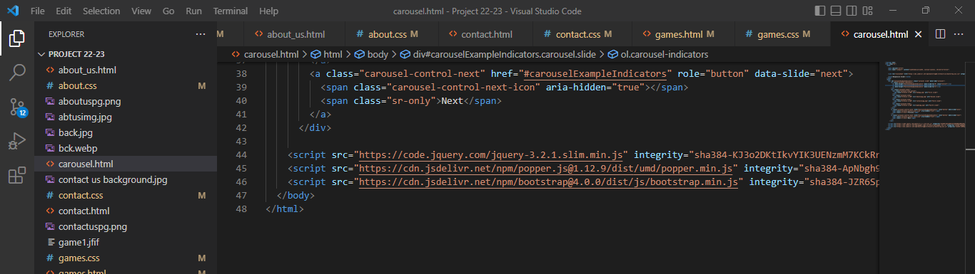

gg

